

**Monetary policy in extraordinary times**

Speech given by

David Miles, External Member of the Monetary Policy Committee, Bank of England

To the Centre for Economic Policy Research and London Business School, London* 23 February 2011

I would like to thank Jochen Schanz and Gilberto Marcheggiano for help in preparing this talk.

*Hosted at the Royal College of Obstetricians and Gynaecologists.

*"Man proceeds in the fog. Yet when he looks back to judge people from the past, he sees no fog on*

*their path. From his present, which was their far-away future, their path looks perfectly clear to him, good visibility all the way. Looking back, he sees the path, he sees the people proceeding, he sees their mistakes, but he doesn't see the fog."*

Milan Kundera, Testaments Betrayed

There is a great temptation to believe that the times we live in are extraordinary. By definition that is generally not true. But I think it is true today when we think about what is happening in the economy.

Towards the end of 2008 we had a financial crisis that took the UK (and other countries) close to a position where the banking sector stopped functioning – an event, had it happened, that would have been about as severe as a prolonged failure of all energy supply. For the UK, this was probably the most serious banking crisis in its history.

In the aftermath of that crisis there was a period when output, and confidence, fell on a scale that was as serious as during the first stage of what we now call the Great Depression (see Figure 1). In the first months of 2009 world trade fell at a pace that one associates with the start of a world war.

Between the middle of 2008 and the Spring of 2009 world commodity prices roughly halved. Since then – that is since the period when the world (and not just countries whose banking systems were most damaged) seemed likely to be descending into a global slump – we have seen many commodity prices (in sterling) nearly double (Figure 2).

# Figure 1: Level of output relative to pre-crisis trend during past recessions1

Years from start of the recession

100

1

2

3

4

5

6

7

2008

1990

1979

1929

1973

Index based in year of peak level of output

98

96

94

92

90

88

# Figure 2: Commodity prices (in £, Jan 2007 = 100)

300

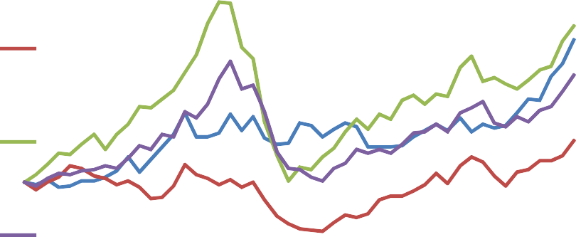

Agriculture and livestock

Industria l Metals

Oil

Total Commodities

250

200

150

100

50

0

Jan/07 Jan/08 Jan/09 Jan/10 Jan/11

*Note: The total commodities series uses the GSCI index.*

1 I use GDP and trend growth estimates from Hills, Thomas and Dimsdale (Bank of England Quarterly Bulletin 2010) to create this chart. The authors use a Hodrick-Prescott filter to separate the trend and the cyclical components of real GDP growth. I assume that their trend growth estimate at the start of each recession would have prevailed during the following seven years had the recession not occurred. The chart shows deviations of actual GDP from this projected trend growth. The dotted line for the latest recession uses the MPC’s mean projection for output growth over the forecast horizon as reported in the February 2011 *Inflation Report.* The latest data for GDP are, of course, subject to revision.

We have also seen fiscal deficits rise to levels unprecedented in peacetime. For the UK the Office for Budget Responsibility estimates that between 2007-08 and 2012-13 the stock of public sector net debt will have roughly doubled as a percent of GDP – from around 35% to close to 70%. If we include that debt, and take account of the debt of the banks now classified to the public sector, the picture is even more remarkable (Figure 3).

# Figure 3: Public sector stock of net debt (% of GDP)2

300

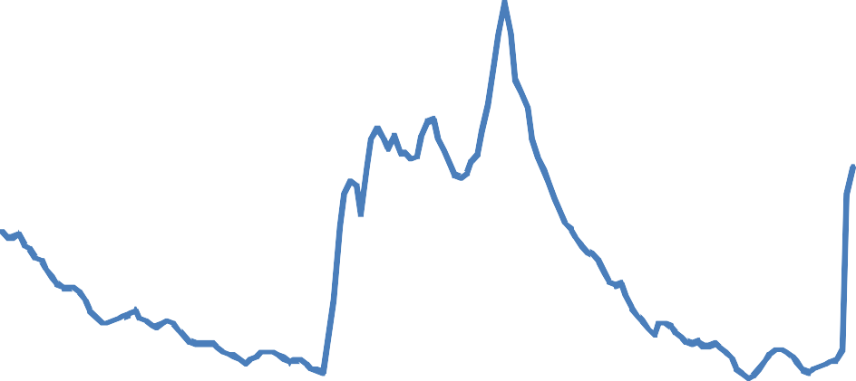

250

200

150

100

50

0

1855 1875 1895 1915 1935 1955 1975 1995

*Source: 1855-2007 Hills, Thomas and Dimsdale (Bank of England Quarterly Bulletin 2010), 2007-2009 ONS series code ‘RUTO’.*

One aspect of how extraordinary this period is – how unlike a textbook economic cycle it is where a period of well under trend growth is followed by a period of above trend growth – is illustrated by Figure 4 which shows the evolution of the level of GDP since 2007 and an assessment made by the MPC of the chances of the level of GDP following different paths over the next three years.

The level of GDP now – in early 2011 – is about 10% below where one would have expected it to be had the UK experienced average (by its own past standards) growth from the start of 2007. I think a reasonable view is that growth over the next three years is about as likely to be above as below the long run average rate.

That is pretty much what is implied by the projection shown in Figure 4 where the average outcome – based on an assessment of the risks around a central path – is that growth is close to the long run trend. This is not a pessimistic forecast relative to judgements currently being made by other forecasters. **If** that is how things evolve – and of course the overwhelming chances are that it will be either worse or better than that – it

2 The ONS calculate public sector net debt as financial liabilities less liquid assets and does not include all assets and liabilities of the public sector. The public sector, including the banks classified to the public sector, owns considerable amounts of illiquid assets, but these are not taken into account in the calculation of net debt.

would mean that in the 4 years since the start of 2010, when output had stopped falling and at the start of what some people might call “the recovery”, then there would have been no significant return to the pre-crisis trajectory of economic activity in the UK. (That is similar to the message in Figure 1).

So what is unusual about the recent very sharp recession is both its depth and the probable absence of a subsequent period of consistently above trend growth.

# Figure 4: Projected level of GDP

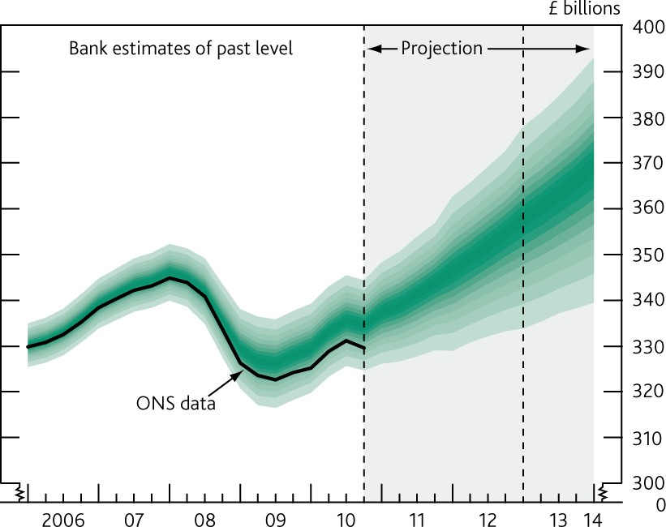

*Source: Bank of England Inflation Report, February 2011. The width of this fan over the past is to take account of likely revisions of the data.*

This is a very sobering picture; some might call it bleak. Anyway what it is clearly not is a standard text-book cycle when the lost output in the downswing is offset by what happens in the upswing. And Figure 1 suggests that by the standards of the big recessions of the twentieth century – and not just relative to average ups-and-downs of textbook economic cycles – we are seeing something unusually severe. This is one aspect of how serious the crisis and its aftermath have been.

Self evidently not all parts of the world have been affected like this; though when things were at their worst at the end of 2008 and in the first part of 2009 that was not so clear. Since then those parts of the world where banking systems were less damaged, and/or mattered less to the economy, have seen a strong rebound.

Growth in emerging economies has been fast – close to 7% in 2010 – and is expected to continue at a similar pace during 2011. That is a major factor behind the roller coaster ride of commodity prices. I think the best explanation behind the extraordinary decline in commodity prices between the middle of 2008 and the Spring of 2009 – when the prices of many commodities halved – is that it appeared at that time that a

financial crisis would cause a global depression from which it would be hard to exit. Since then, many commodity prices have roughly doubled. There has been an almost complete recovery in the level of economic activity in the fast-growing parts of the world. These are parts of the world which have the greatest intensity of demand for commodities. They are back on the steeply rising trajectory they were on before it seemed the world economy was collapsing. It is no accident that most commodity prices are also – roughly – back to where they were in mid-2008.

Where does the UK stand amidst all this? Not in a great place. We have a large banking sector – which is one reason why the downturn was very sharp, the hit to confidence severe and there has been little or no recovery of the lost activity. We are also highly reliant on imported commodities – whose recent dramatic rise in price has reflected recovery in parts of the world where the financial crisis does not seem to have done any lasting harm. The UK also now has a very large fiscal deficit, and has had a substantial and long lasting current account deficit which reflected low public and household sector saving rates rather than unusually strong investment. We also have a current rate of inflation of around 4%.

This is – as the old joke goes – not a nice place to start from. Re-balancing of the economy requires a tightening in fiscal policy, a rise in exports relative to imports, almost certainly a higher saving rate from households and more investment. We need that re-balancing to happen while confidence is fragile, unemployment has gone up significantly and inflation has moved substantially above the 2% target level. The forces that will bring about re-balancing are already at work. Following the very large depreciation in sterling of 2007-08 the exchange rate is at a much more competitive level; fiscal policy is being tightened. But the factors that will bring about re-balancing also generate short term inflation pressures: the rise in the rate of VAT and the fall in the exchange rate mean – all else equal – higher inflation pressures for a period. Factor in the impact of the huge rises in commodity prices over the past year (in excess of 30%) and you would anticipate a serious inflation problem.

And we do have an inflation problem. Inflation on the CPI measure over the year to February is at 4% – double the 2% target. As an MPC member I find it deeply worrying that this should be so. More importantly, for the typical UK household – whose income might be rising at a rate that is barely at 2% – a rate of inflation of around 4% means a significant fall in the standard of living.

But for a moment I want to step back and ask a simple question about inflation: Why isn’t it higher?

Estimates from the Bank’s latest *Inflation Report* suggest that if shocks from changes in VAT, energy prices, and import prices had hit us in normal circumstances, inflation might well have climbed to 6% or 7% over the past year. Figure 5 is from that *Inflation Report*. It shows a range for the estimated impact of these factors on CPI inflation over the past year. That range has stretched as high as 5% and is now between 2% and 4%. This is an estimate of how much higher than normal inflation is because of tax rises and increases in the cost of imported materials and goods. So if, in their absence, we would have see inflation at about the

2% target level then what Figure 5 suggests is that the import price rises and VAT might have been expected to generate a path for inflation over the past year that was between 4% and 7%. The average over the past year might have been around 5% or 6%. Actual inflation has not been that high. So it looks like some other factors have been working in the opposite direction. The lower band (in green) in Figure 5 illustrates that. It is an estimate of CPI inflation excluding the impact of the rise in VAT, of commodity prices and of rises in other imported goods. That rate of inflation looks like it would have been close to zero – considerably below the 2% one might have expected under normal economic conditions.

# Figure 5: CPI inflation and the contribution of VAT,

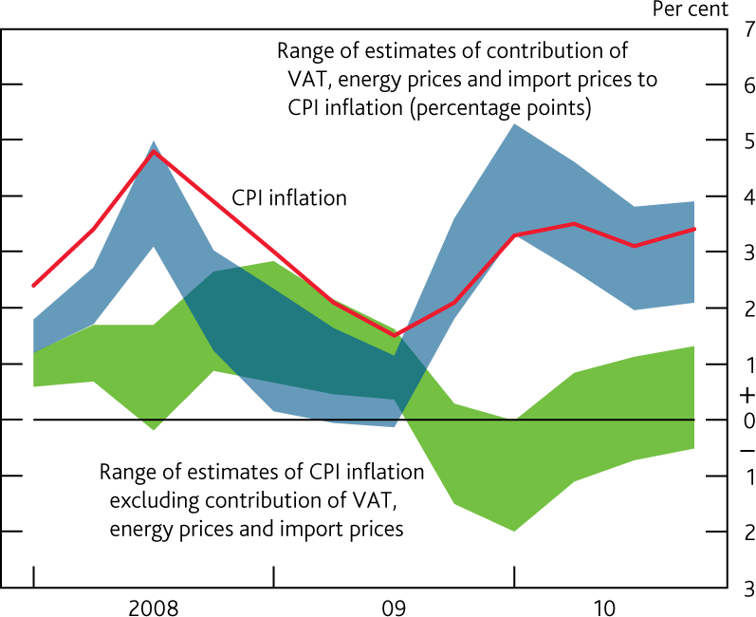

*Note: The blue swathe sums the minimum and maximum of the individual estimated impacts of VAT, energy prices and import prices on CPI inflation.*

There is a legitimate question as to whether it makes sense to look at the impact of tax changes, shifts in commodity prices and movements in the exchange rate upon prices and estimate what inflation might have looked like without those factors. If those things themselves reflected actual and expected monetary policy – and in particular the expectation of very expansionary monetary policy – then it would not be sensible to calculate what inflation might have been in their absence, but with monetary policy held where it was. For a small economy like the UK it seems to me clearly legitimate to think that the path of commodity prices has not had much to do with how monetary policy was set by the Bank of England. The changes in VAT were also not something driven by monetary policy – but rather a policy response to the huge changes in the economy that came in the wake of the financial crisis and to which monetary policy has also been responding. Things are not so clear cut with the exchange rate, where there can, in general, be expected to be a link between current and expected monetary policy and shifts in the value of the currency. But it strikes

me as very unlikely that the big depreciation in sterling – all of which happened in 2007 and 2008 (and since when sterling has been stable) – reflected loose monetary policy. Interest rates ended 2007 higher than at the start of the year; they stayed at a level in excess of those set by the Fed and ECB; and actual and expected inflation stayed close to target. Interest rates were cut in 2008 but the major criticism made (largely in retrospect and largely ignoring the fog that Milan Kundera notes is part of life) of the MPC was that interest rates were not cut by enough in 2008 and that policy was far too restrictive. So I think it is a strange interpretation of history that says that the exchange rate depreciation of 2007-08 was a reflection of a loose monetary policy.

Let me get to the key question. What is the right response of monetary policy to the extraordinary combination of events we have seen over the past three years which I have been describing? That is the question the each member of the MPC faces and I want to explain how I see the answer. But just before coming to it let me just remind you what the response has been – and I am aware that a description of what we have done and an analysis of what the right thing to do is are not necessarily the same thing. On the surface it looks a remarkable response – for two years now Bank Rate has been at the lowest level in the history of the Bank of England (effectively zero). There has been a tripling of the Bank’s balance sheet as we have purchased assets on a huge scale to loosen monetary policy yet further. If all you knew about the past few years was the inflation rate and the setting of monetary policy – and nothing else – you might conclude that monetary policy has been set so as to generate inflation. You might also think – if you looked back at the history of the last 300 years – that this monetary policy had not been very powerful. The most expansionary monetary policy in the history of the country had only generated a rise in inflation to 2% above the target.

Of course that would be a very bizarre interpretation once one took into account the circumstances. The reasons for relatively high inflation today are not because Bank Rate is close to zero and the justification for monetary policy being so expansionary is self-evidently not to be sought in today’s rate of inflation. Further the observation that Bank Rate is close to zero – in isolation – very significantly overstates the degree to which policy has been loosened since the days of 5% Bank Rate. The weighted average of mortgage rates, bond yields for corporates, rates on household unsecured credit and the cost of bank borrowing for companies is probably down by about 150bp since then; Bank Rate is down by 450 basis points. What matters is the cost of debt – and the return on savings – for households and companies. Even at ½% Bank Rate, those rates are in most cases only marginally down on levels of 2006-07 (Figure 6). And of course that Figure only shows interest rates for those that are able to borrow.

# Figure 6: Interest rates faced by households and firms3

Bank Rate

Household unsecured borrowing rate

Household deposit rate

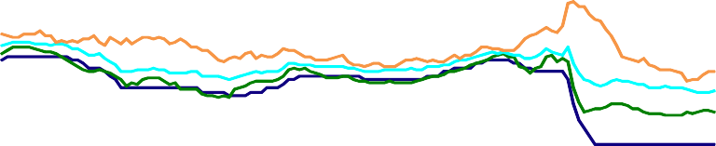

Household secured borrowing rate Corporate borrowing rate (bond yields)

Per cent

20

15

10

5

0

00 01 02 03 04 05 06 07 08 09 10 11

*Source: Bank of England and Bank of America Merrill Lynch.*

Let me come back to the key question of what is the right setting for monetary policy. That must depend on what the most likely profile for inflation is and the risks around it. And that depends on international forces largely outside the influence of the UK – for example commodity prices – as well as on domestic factors more directly influenced by monetary policy – the evolution of demand relative to the supply potential of the economy. I think the analysis of those factors outlined in the *Inflation Report* published last week – which is a collective judgement by the MPC – is one which largely reflects my own assessment.

For me the three big features of the current assessment made in that *Inflation Report* – all of which I think are reasonable – are these:

First, inflation is likely to be significantly above target for all of 2011, for reasons that we can understand (at least ex-post) and overwhelmingly reflect rises in commodity prices, changes in VAT and increases in the sterling prices of other imported goods. The significant upward shift in the 2011 projected path for inflation since last November very largely reflects rises in the level of commodity prices since then – nearly all of which are assumed to be permanent. I don’t think the risks relative to that assumption (that the rise in commodity prices is not set to be reversed) are obviously skewed to the upside.

Second, inflation is likely to fall back quite sharply to target during 2012 – and the risks are then pretty much evenly balanced for it being either side of 2% thereafter.

Third – and as noted above – the central outcome is that growth from here on forward is only about at its historical average, or maybe marginally above it. Should that be how things evolve I believe it means that

3 Note: The corporate borrowing rate series uses an index of BBB-rated sterling corporate bonds issued by non-financial companies with a current average maturity of 8.5 years. The household lending and deposit rate series show data on quoted rates by UK Monetary and Financial Institutions.

higher unemployment and some unused capacity persist. I think the risks to that central view are also skewed to the downside.

This outlook for inflation and for growth is all conditional on Bank Rate following a path implied by market rates which would mean a very gradual removal of the current very accommodative stance of monetary policy. **If** one knew that the outcomes would evolve in line with those central profiles for activity and inflation I don’t see a strong case now for significantly accelerating the process of tightening relative to that. One reason is revealed by Figure 7. That shows an estimate of the most likely path4 for seasonally adjusted quarter on quarter CPI inflation consistent with the latest *Inflation Report* projections (conditioned on market rates). That falls back to a rate consistent with the target (0.5% a quarter, so 2% at an annualised rate) by the start of 2012. The actual annual rate of inflation at that point is likely to be higher because that reflects price increases over the course of 2011 when the reaction to recent rises in commodity prices and to VAT is still being felt.

# Figure 7: Quarter-on-quarter inflation rates, seasonally adjusted.5

Percentage change on a quarter earlier

3

2

1

0

2005 2006 2007 2008 2009 2010 2011 2012 2013 2014

To be clear, I think monetary policy ***could*** be set so that it is likely that inflation moves back to target significantly more rapidly than is implied by the central profile in the *Inflation Report* fan charts. Indeed I would go further and say that inflation could probably be brought back to target very fast, perhaps even over a few months. For that to happen, and in the absence of a sharp reversal of the recent rises in commodity prices, it would probably need both a big appreciation of sterling and a significantly greater degree of slack in the UK economy (and higher unemployment) to bring domestically generated pressures down enough to

4 “most likely” is not the same as “likely” – the chances of things playing out along the lines of the chart are actually small. But I don’t know in which way they will deviate from it.

5 The seasonally adjusted data are calculated using a Census X12 process over 1988 to 2010. Over the forecast period, the assumption is that the average seasonal pattern seen since 2005 continues. Projections from 2011 onwards are for the mode.

offset the impact of recent rises in prices of imported goods and in VAT. One could use monetary policy to try to engineer that. But I am very sceptical about whether it is desirable:

1. A substantial appreciation of the exchange rate might add to volatility of output in the short term and be unhelpful for re-balancing
2. More slack in the economy probably erodes productive potential and means the levels of output and employment consistent with meeting the inflation target further ahead are lower
3. A sharp tightening in monetary policy now needed to bring inflation to target in the very near term would quite likely mean easing policy again aggressively next year creating volatility

I think the trajectories shown in the *Inflation Report* represent a better way of balancing inflation risks than would be likely if policy was set now to accelerate a return to target at a rate substantially faster than implied by Figure 7. Of course no-one should feel greatly confident that inflation will follow the central path and gradually move back to target over the course of next year. But I do not believe the profiles are obviously biased or excessively optimistic. For the forecast the assumption is that following the big recent rises in commodity prices today’s higher prices are here to stay. That is not a rosy tinted view that the cost pressures are soon reversed.

I am not for one moment denying that there is a risk of domestic wages and prices being pushed up as inflation expectations rise and the credibility of the MPC declines. But I think that risk is reflected in our fan charts. And it is a risk that I don’t think is most effectively handled by tightening policy at a rate faster than those fan charts suggest is desirable. I also think the credibility and inflation expectations risks are ones best countered by presenting the evidence on inflation, and an interpretation of it, and explaining the response to it rather than by a speed of tightening in monetary policy which – on the basis of the chances of different outcomes – is not one we should obviously adopt.

I think one thing should certainly be avoided. This is to try to deflect legitimate questions about past

(ex-post) forecast errors by showing how tough on inflation one is with a tightening in policy on a scale which the assessed profiles for inflation and growth do not warrant. The best way to handle past forecast errors – and the MPC forecasts for inflation have been below outturns – is to try to understand why they happened and use that to make the best assessment today of where we might be going next. In doing that we should – like Milan Kundera – be mindful of the amount of fog that existed in the past and the amount that is still around today.

As I said earlier you would not want to start from here. But one of the few things we do know with absolute certainty is that here is where we are.

How do we stop this sort of thing happening again? How do you reduce the chances of having to start from a nasty position like this again?

One aspect of that is to make the financial system – and banks in particular – more robust. The reason this downturn has been so severe – and the reason that “downturn” is therefore too feeble a word to describe it – is that it started as a result of a banking crisis. If we can much reduce the chance of that happening we much reduce the chance of having to start from here again. One way to make the banking sector much more robust is to have banks use much more equity and less debt to finance their activities. I recently wrote

– with colleagues at the Bank of England – about the best way to achieve that.6 The question we explored was what degree of leverage, or equivalently what mix of equity and debt, might be appropriate for banks. We presented evidence that pointed towards the desirability of very much greater levels of equity financing – and very much lower bank leverage – than we have seen in recent years (Figure 8). Lower leverage is something that is happening already and the implementation of the capital rules that go under the name of Basel 3 will take it further. The question is how far to take it – and that depends on the cost of having banks use more equity (and less debt) and the benefits from having a banking system better able to withstand shocks to the value of its assets. I am not going to repeat the analysis done in that Discussion paper – the paper is readily available and its sets out the estimates of costs and benefits in detail.

# Figure 8: UK Banks’ Leverage Ratio 7(a)

40

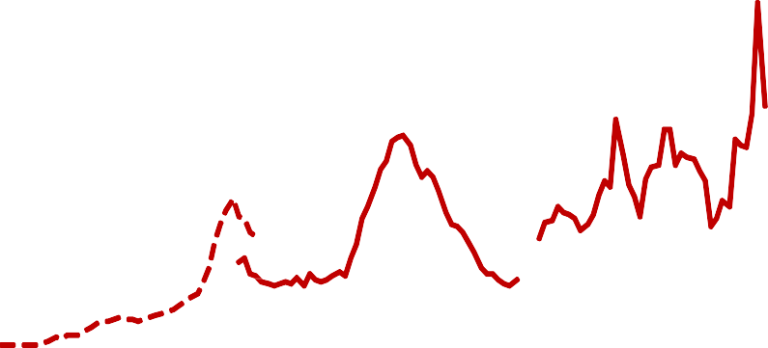

(b)

(c)

35

30

25

20

15

10

5

1880 1900 1920 1940 1960

0

1980 2000

*Source: United Kingdom: Sheppard, D (1971), The growth and role of UK financial institutions 1880-1962, Methuen, London; Billings, M and Capie, F (2007), 'Capital in British banking',*

*1920-1970, Business History, Vol 49(2), pages 139-162; BBA, ONS published accounts and Bank calculations.*

6 “Optimal Bank Capital”, by David Miles, Jing Yang and Gilberto Marcheggiano, External MPC Unit Discussion paper no 31, January 2011 . Available at: <http://www.bankofengland.co.uk/publications/externalMPCpapers/extMPCpaper0031.pdf>

7 (a) UK data on leverage use total assets over equity and reserves on a time-varying sample of banks, representing the majority of the UK banking system, in terms of assets. Prior to 1970 published accounts understated the true level of banks' capital because they did not include hidden reserves. The solid line adjusts for this. 2009 observation is from H1.

1. Change in UK accounting standards.
2. International Financial Reporting Standards (IFRS) were adopted for the end-2005 accounts. The end-2004 accounts were also restated on an IFRS basis. The switch from UK GAAP to IFRS reduced the capital ratio of the UK banks in the sample by approximately 1 percentage point in 2004.

But let me stress a few things:

First we find that under a wide range of assumptions the scale of the benefits from having banks use a lot more equity than they have today very substantially outweigh the costs. This is why I conclude that having banks come to have capital ratios that might be more than twice as high as today (and also higher than under the Basel 3 rules) is likely to be desirable. The impact on the average cost of bank funds of having capital twice as high as today’s levels might only be of the order of 20bp – one fifth of one percentage point.

That would lead to a higher cost of bank-intermediated credit, somewhat reduced investment in the

non-financial sector, and a lower long-run level of GDP. We estimate that this decline in GDP will be very small: perhaps around one sixth of one percent of GDP. In contrast, the estimated benefit of doubling capital (or halving leverage) was estimated as being over 10 times as great.

The second point to stress is that were banks, over time, come to use substantially more equity and correspondingly less debt, they would not have to dramatically alter their stock of assets or cut their lending. The change that is needed is on the funding side of banks’ balance sheets – on their liabilities – and not their assets. The idea that banks must shrink lending to satisfy higher requirements on equity funding is a non- sequitur. But there is a widely used vocabulary on the impact of capital requirements that encourages people to think this will happen. Capital requirements are often described as if extra equity financing means that money is drained from the economy – that more capital means less money for lending. Consider this from the Wall St. Journal, in a report on the Basel negotiations on new rules over bank capital:

# “The proposed rules would have driven capital requirements up for all banks, forcing the quality and quantity of these capital cushions to grow …… That would be expensive for banks, because the money sits on banks' balance sheets and essentially can't be invested to bring in more profits.”8

This is pretty much the opposite of the truth. At the risk of stating the obvious:

*Equity is a form of financing; other things equal a bank that raises more equity has more money to lend – not less.*

Nor is the capital in any sense “tied up”; it represents funding available to a bank to lend or to acquire other assets.

The final point to note is that there is no necessity to move to a position where banks use much more equity financing, and have lower leverage, in a short period. This is a move that is not one which has to be made in a year or two. The big question here is what the banking system should come to look like to reduce the

8 “Inching Towards World-Wide Accord on Bank Rules”, Wall St Journal, August 30th 2010.

chances of the sort of mess we are now dealing with happening again – happening to our grandchildren and their grandchildren and their grandchildren. This is a time for long-term thinking. After there has been an earthquake which has caused huge damage and loss of life it is sensible to think about how you build buildings; but you don’t knock down every building that is still standing and try to re-build everything immediately.

When you allow banks to gradually increase their use of equity – and gradually reduce their leverage – over many years the difficulties of making the transition can seem very much less. Consider the following simple scenario. Suppose during each of the next 15 years, banks retire 5% of their currently issued debt securities and replace them with equity. These debt securities today make up about 15% of major UK banks’ balance sheet; they do not include bank deposits. If while doing this banks also continued to retain about 50% of their post-tax equity earnings, as they have done in the past, they could triple the amount of equity relative to their assets within the next 15 years while still allowing their assets to grow by about 7.5% in nominal terms.9 If banks used these funds to expand only lending to their customers, they would be able to fund an even higher growth rate for lending while still increasing their capital ratios to 20% by 2025.

What we need to do is to think about the overall net economic costs of having a different banking structure that you get to over a prolonged transition, instead of thinking of the private cost to banks of them hurtling towards a different position over the course of a year or so.

That is the issue that the Banking Commission chaired by Sir John Vickers is addressing. I am sure that it is precisely this sort of long view – a view across many generations rather than across a few years – that they are taking.

9 This assumes that RoE declines by about half the amount that Modigliani-Miller would suggest. This is in line with the estimates we found in our discussion paper. If banks instead retained 75% of their post-tax profits, they would have enough funds to allow their assets to grow by about 10%.